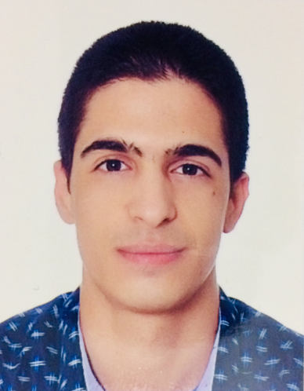

**MOHAMMED EL HAOUAT**

22 years old

N181 hay al qods bensouda Fes

0619776739

Mohammed.elhaouat.1707@gmail.com

**EDUCATION**

**2015 Bachelor of Mathematics B with honors A. Good**

***Fez*** Ibn Hazm Highschool in FEZ

**2018**  **Two years in preparatory classes**

***Fez*** National school of applied sciences of Fez

**2019 One year in Mechanical Engineering and Automated Systems**

***Fez*** National school of applied sciences of Fez

***Languages :* French:** fluent

**English:** fluent

**Arabic:** maternal

**Other languages : Spanish and German : beginner**

***Computer skills:*** Word, Excel, Powerpoint, C programming , Computer Aded Design Softwares

**Sept – Oct . 2019 Directel**

***Fez* Making appointments (for the canadien company Videotron)**

**Nov – Dec . 2019 BipCall**

***Fez* Telemarketing (for two belges companies Proximus and VOO)**

Discipline and punctuality

Initiative

Communication skills

Extreme sport, reading, painting

Sports, Formations, Passions, Projets xxxxxxxxxxx xxx xxxxxxxxxxxxxxxxxxxxxxxxxxxxx xxx xxxxxxxxxxxxxxxxxxxxxxxxxxxxx

**WORK EXPERIENCE**

**SKILLS**

**INTERESTS**